**MID-TERM EVALUATION REPORT**

Submitted in the partial fulfilment of the requirement for the award of the degree of

**BACHELOR OF ENGINEERING**

**IN**

**INFORMATION TECHNOLOGY**



**DEPARTMENT OF INFORMATION TECHNOLOGY**

**UNIVERSITY INSTITUTE OF ENGINEERING AND TECHNOLOGY**

**PANJAB UNIVERSITY, CHANDIGARH.**

**2023**

Undertaken at:

**INCEDO Inc.**



***Submitted by:***

Sakshit Goel

UE198084

8th Semester

**ACKNOWLEDGEMENT**

I am grateful of Incedo Technology Solutions Pvt. Ltd. To give an exposure and training in the industrial environment. A successful project is a complete mix of a number of things which include not only hard work of the team members but also the ideas and efforts put in by the people who guide them towards achieving success. Hence it is really an important task to acknowledge all the beneficiaries of the Incedo North stars. It was a great learning experience as I am introduced to various aspects of the working of the organization.

I am indebted to ‘University Institute of Engineering & Technology, Panjab University, Chandigarh’ for giving me an opportunity to pursue Industrial Training at Incedo Technology Solutions Pvt. Ltd. This training has enabled me to empower myself with the knowledge of the existing trends in the world of technology and further enhance my knowledge in IT sector.

**CONTENTS**

|  |  |  |
| --- | --- | --- |
| **SL. No.** | **Content** | **Page No.** |
| 1 | Company Overview [1] | 4 |
| 2 | Training Overview  2.1 Engineer Primer  2.2 Testing Training  2.3 Four Weeks Capstone Project  2.4 Future Prospects | 9  9  11  12  17 |
| 3 | References | 18 |

**COMPANY OVERVIEW [1]**

Incedo is a New Jersey based consulting, data science, and technology services firm, founded in 2011. It empowers companies to realize sustainable business impact from their digital investments with our integrated digital transformation consulting services and AI platforms.

Incedo is a Bay Area headquartered, consulting, analytics, and technology services firm, working across the Financial Services, Life Science, and Communication Engineering sectors, enabling its clients to maximize business impact through emerging technologies.

Incedo Inc. has over 3,000 people in the US, Canada, Latin America and India and a large, diverse portfolio of Fortune 500 enterprises and fast growing clients worldwide, working across telecom, financial services, product engineering and life sciences.

**Mission:**Enable our clients to maximize business impact from technology by:

* Harnessing the transformational impact of emerging technologies.
* Bridging the gap between business and technology.
* Become an employer of choice by being ‘employee first’ in all processes and practices.

**Vision:**A World-Class Technology Services Firm that is a trusted, long-term partner for global enterprises, is recognized as an industry leader in chosen emerging technologies, is an employer of choice, and delivers superior growth and financial performance.

The company has prestigious clients all over the world. Some of these clients are US Bank, Citi Bank, Cisco, Belden, Verizon, Tripwire, Syneos health, Pfizer, Genentech and much more.

The company operates with 8 core values:

1. Exceed Client Expectations

2. Pursue Excellence

3. Build for the long term

4. Embrace change and Innovation

5. Work as one Global team

6. Be a Caring Meritocracy

7. Drive commercial rigor

8. Always act with integrity

**Office locations across the globe:**

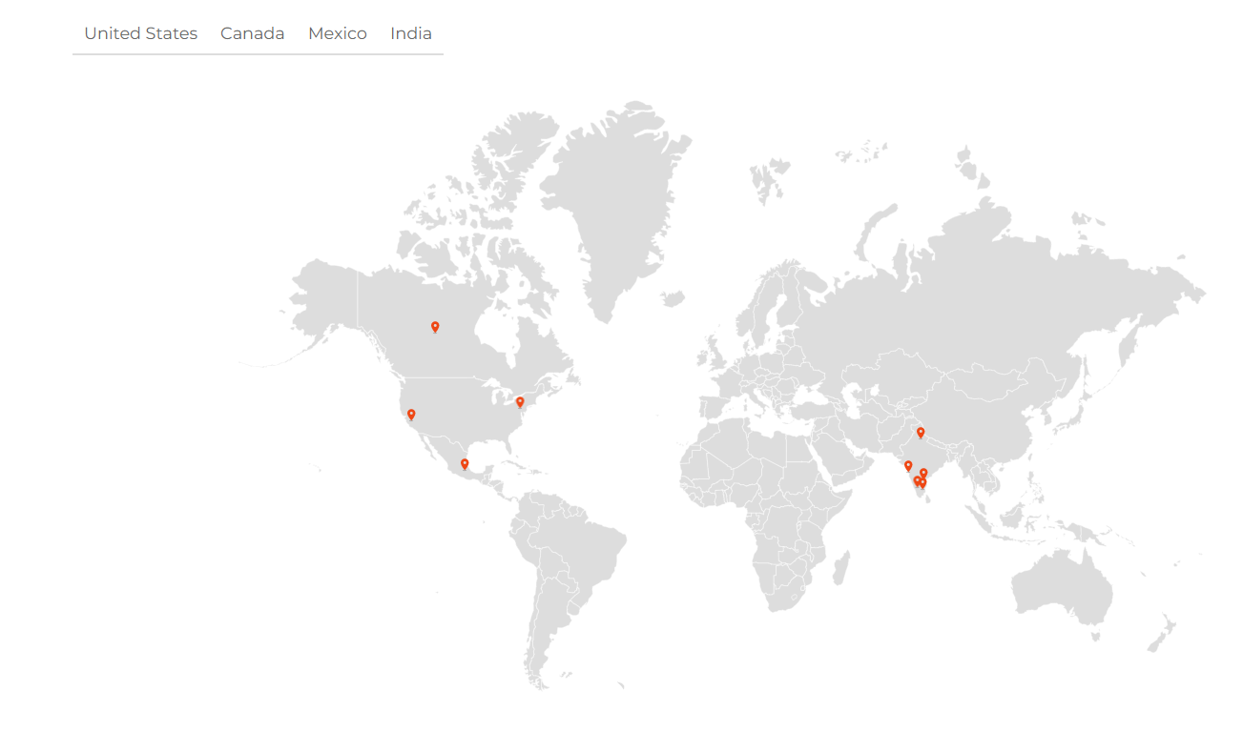

**Office locations across India:**

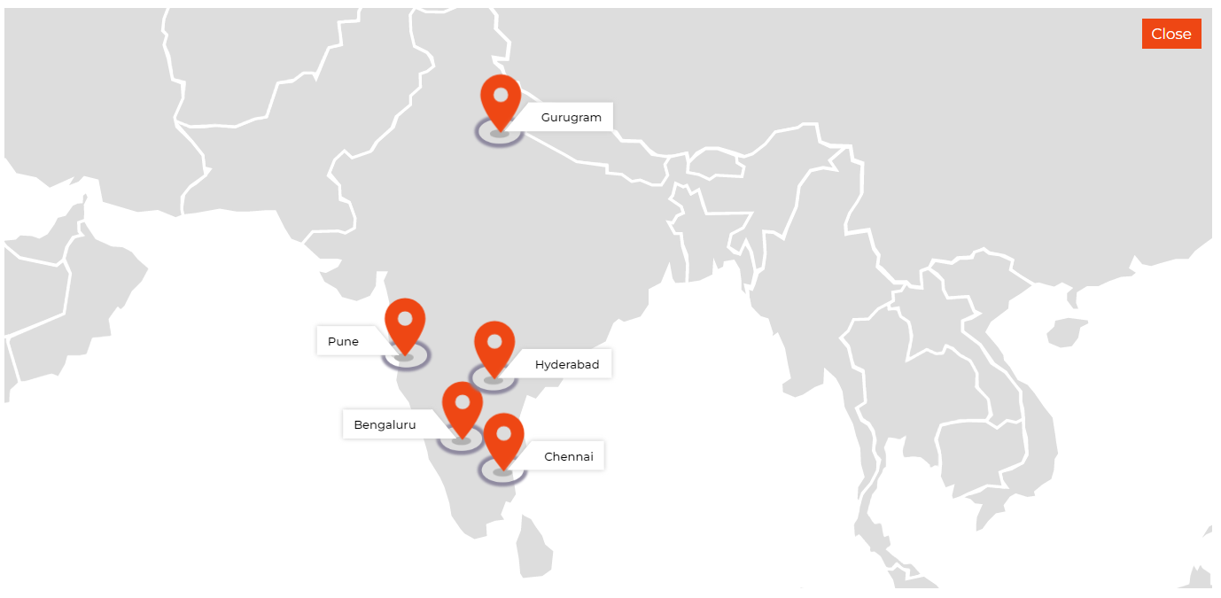

**COMPANY INDUSTRIES**

There are mainly 4 verticals in which the company deals in Telecom, Life Sciences, Financial Services and Wealth Management, Product Engineering. Along with this, the company provides 2 products to its customers Incedo Pay and Incedo Lighthouse.

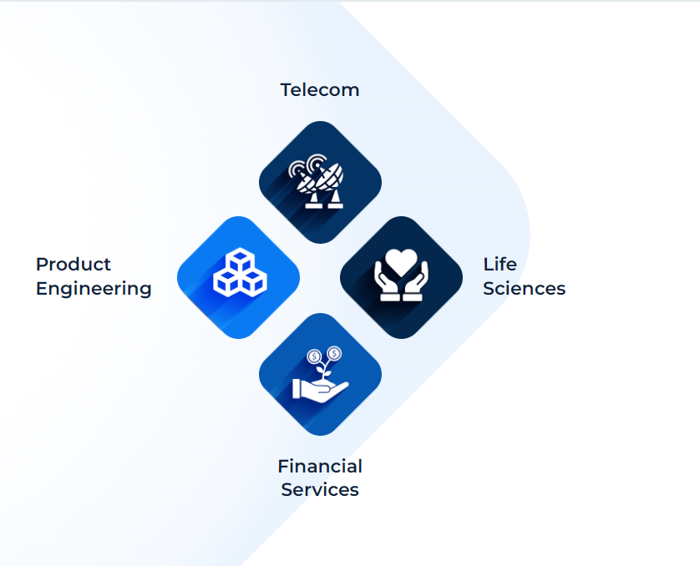

Product Engineering: Incedo partner with you to speed up and scale your product innovation by blending design with our strong engineering and domain expertise.

Financial Services: Incedo combine our domain expertise with proprietary data and payments platforms to speed up your digital transformation journey.

Life Sciences: Incedo help you to enable holistic patient experiences, understand the gap between insights and action and reimagine care delivery models with connected care solutions.

Telecom: Incedo help you to unlock the full potential of 5G by transitioning to a leaner infrastructure, rolling out intelligent edge networks and enabling an excellent online customer experience.

**COMPANY SERVICES**

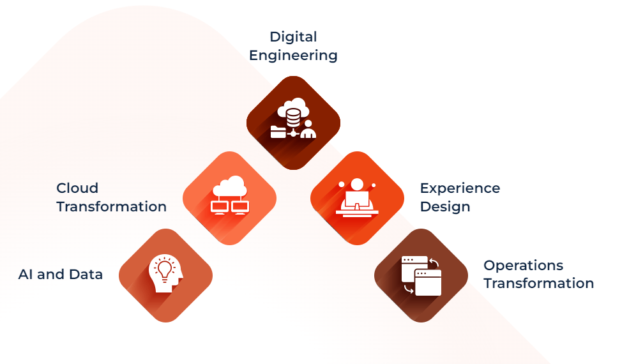

Digital Engineering: Incedo empowers you to remain agile in a world of changing customer and business needs by upgrading your legacy applications and systems to cloud-based solutions.

Cloud Transformation: Incedo works at the intersection of domain, data and technology to move your applications and data platforms to the cloud so that you can harness the power of cloud computing.

AI and Data: Incedo brings world-class capabilities in AI, data engineering and analytics combined with deep domain expertise to deliver impactful business solutions.

Experience Design: Incedo combines design thinking, data science and innovative technology to create full-stack, customer-centric experiences that deliver significant business impact.

Operations Transformation: Incedo combines our domain depth with experience in process diagnostics and automation technology to design and execute transformational solutions.

**TRAINING OVERVIEW**

I have been offered the role of a Quality Assurance engineer, which entitles the task to ensure the quality of the software and systems the company offers to its clients.

My role is to test the system rigorously in the environments similar to that of the client and deployment so that there is minimal errors and minimal application failures.

But in this project I have been laid with the responsibility of the UI part of the project so I have been working the React JS language for the frontend development.

**2.1 ENGINEER PRIMER**

This was the onset of our training as engineers in the company, which was same for all no matter their role. It was a basic engineer’s tutorial where we learnt various aspects of software engineering very briefly.

Various Technologies learnt included:

**Agile methodologies** are a set of software development practices that prioritize iterative and collaborative approaches to project management. The goal of agile methodologies is to deliver high-quality software quickly and efficiently by breaking down development tasks into smaller, manageable pieces and responding to feedback throughout the development process.

Some of the most popular agile methodologies include:

* Scrum: A framework for managing and completing complex projects that emphasizes collaboration, flexibility, and continuous improvement.
* Kanban: A visual framework for managing work that emphasizes visualizing workflow, limiting work in progress, and continuously delivering small batches of work.

**SDLC** stands for Software Development Life Cycle. It is a process used by software development teams to design, develop, test, and deploy software products. The SDLC process typically involves several stages, each with its own set of tasks, goals, and deliverables.

A **database** is an organized collection of data that is stored and managed in a way that allows for efficient retrieval and manipulation of data.

**Architecture in software development-** like monolithic, Client-server architecture, Micro-services architecture, Service-oriented architecture (SOA)

**Web development** is the process of creating dynamic web applications and websites that are accessible via the World Wide Web. Web development consists of three main components: frontend, backend, and database.

Other technologies learnt included Software testing lifecycle, Coding guidelines and many more.

Post the training we also went through an assessment to ensure that all the training have been properly inculcated

**2.2 TESTING TRAINING:**

Post Engineering Primer we were aligned with our respective tech stack trainings for two weeks where we learnt the basics of software testing lifecycle, various methodologies, types of testing, manual testing.

Under this core tech stack training of testing I learnt the difference between a bug, error, failure and a fault, importance of reliability and its cost on the company business.

Most importantly we can’t test everything but we can test the business requirements, various principles of testing.

Test plan, suite and cases form the basis of manual testing, proper documentation, recording and execution of a test case.

Types of testing include- Performance testing, Regression testing black box, white box, unit, integration, load, usability etc.

**2.3 FOUR WEEK CAPSTONE PROEJCT:**

The following project statement is given as per which we have to make a team project under respective Buddie’s and Mentors

**Project 1 – STAR Project**

|  |  |
| --- | --- |
| Project Name | **Advisor’s Hub** |
| Project Code |  |
| Core Skill Set | Html, CSS, React JS |
| Duration | 4 weeks |
| Mentor | Ankit Jha, Nirmal Rajput |
| Project Details | We are assigned with a sample dummy project in which we have to create a Home, Sign Up, Sign In, Dashboard page for both the advisor and the client.  The objective is to build a react website that allows the advisor to view, analyse, edit and manage the investments laid out by their clients at any moment of time. Several Tools of react like routing, react-hooks, CSS applications and React functions were a major part of the Frontend Use-case which is further integrated with the backend controllers and API’s in order to be Functional and in use.  **Technical Stack to be used ( at least but not limiting to)**   * .Net Core – REST API Creation, Logging, Exception Handling, Design Patterns, User authentication and authorization, Azure AD Integration, Configuration Management, SQL Data Handling, Backend job creation, MS Dynamics integration * SQL Server – Basic SQL Server operations, error handling, transaction management, Procedure and job creation * GitHub/Azure DevOps – Repository and CI/CD tasks * Rest API * ReactJS – UI Development, Session management, User Authentication and Authorization, Azure AD Integration, API Integration, Data exchange with backend, integration with MS Dynamics (if required) |
| Project Content | High level functionality to be implemented   * Role management (Two roles –Advisors, Clients) * Firstly. Home page is displayed at the start which exhibits the Sign Up and Sign In for the advisor and the client. * Advisor would be able to access the dashboard where all its clients with their respective investments could be managed and laid off. * Advisors can manage and edit their clients details. * JWT Authentication is done with the .Net technology which helps to attain the right credentials saved in the database as per the UI data.   Good to have   * Integration with JWT Authentication. * Dynamic updates on the UI, without page refreshes in real time. |
| Tentative Schedule | TBD |

**Week 1** of the project we worked on gathering the user requirement of the system, basically breaking down the project statement to understand the Technical needs. As per the Technical needs figma designs were created to make a roadmap towards the front end of the application.

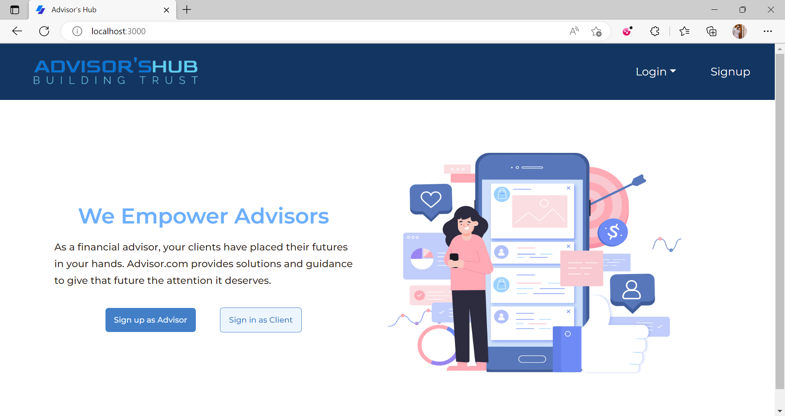  
*Figure: Figma design of Home page*

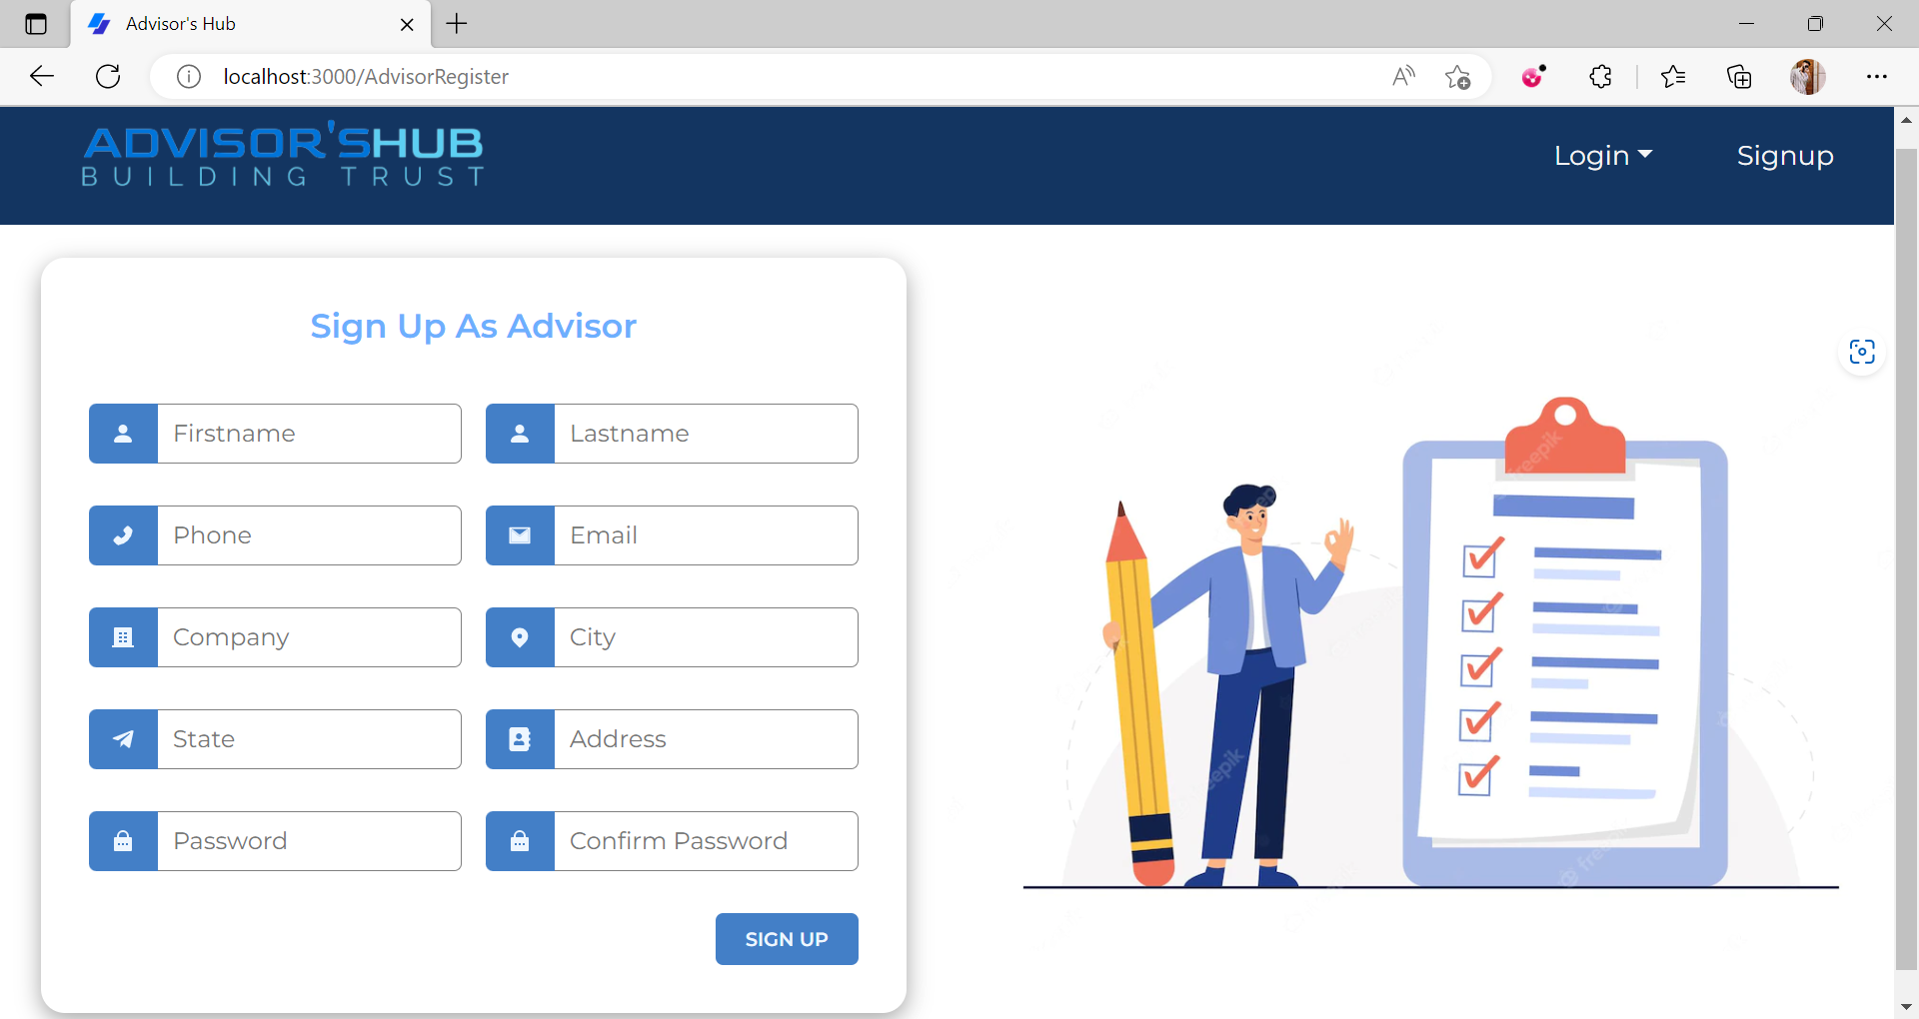

*Figure: Figma design of Advisor Sign Up page*

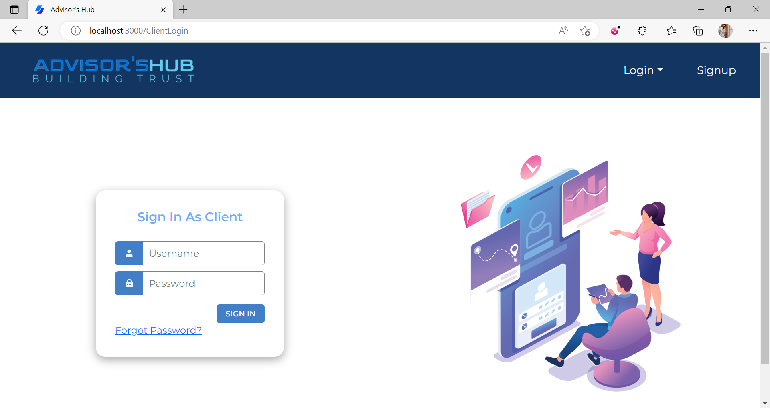

*Figure: Figma design of Client Sign Up page*

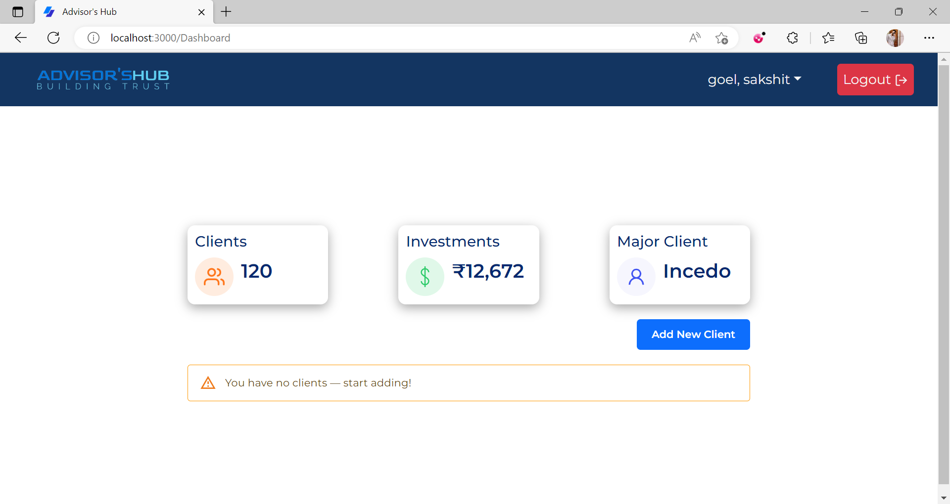

*Figure: Figma design of Dashboard page*

**Week 2** was dedicated to the Building of the User Interface part of the website through React JS core skills. Wherein my personal role as a UI Developer was important to ensure that the coding in the VS Code editor is done as per the Figma Designs and all other CSS commands were implemented according to the UX part of the project.

**Week 3** was dedicated to building the infrastructure and architecture of the Website that how the data will be fetched, analysed, processed and filtered into the system.

High-level implementation of data modelling, Endpoints were tried to be implemented to ensure that the roots of the application system that is the Controllers, API’s, and the JWT Authentications.

**Week 4** was assigned to final evaluation of the work done so far and final quality tests that were to be performed on the application developed so far that is the database- which was already done and the backend for which we use Postman API- a tool to check whether the data being fetched through the API code is same as that of a query run on MySQL server.

Additional tests included that the data that is being fetched is readable, easily manageable and manipulative for the front end to sort and work on.

Manual test cases were also performed as per the functionalities of the buttons and the pages both by the testers and the devlopers.

Alongside the application development timeline as a UI engineer we are supposed to maintain the components of React for the development process which aims the correctness for the key basic Technical requirements and all those key areas which could lead to application failure or loss of business. Some of the screenshots have been attached which lead us to the successful completion of the UI part.

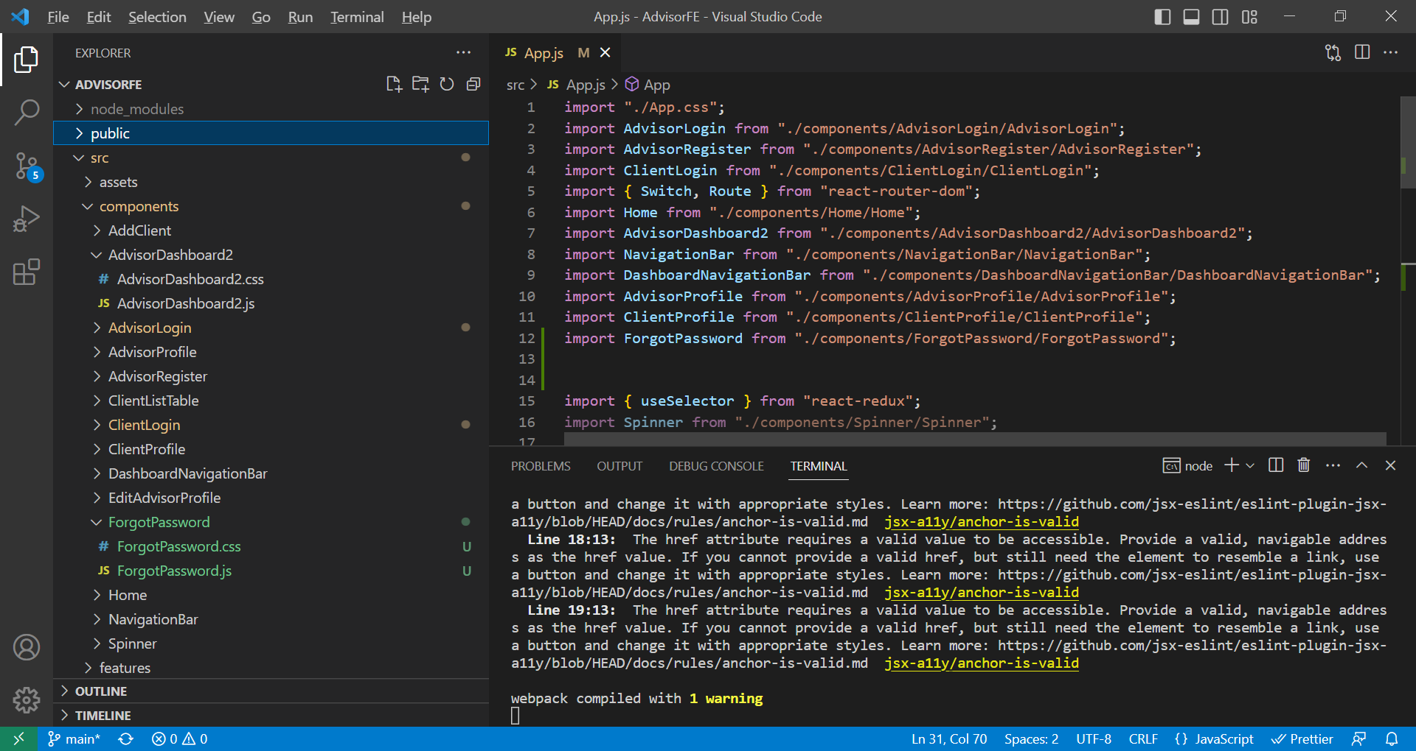  
*Figure: Components of Website*

With the end of 4th week basic evaluations were done to check on our progress and to see our knowledge implementation, team work and the overall skills Incedo wants from us when we work on client project.

**2.4 FUTURE PROSPECTS:**

**1. Making Frontend dashboards using ReactJS**

React is a free and open-source front-end JavaScript library for building user interfaces based on components. In React, you develop your applications by creating reusable components. These components are individual pieces of a final interface, which, when assembled, form the application’s entire user interface.

The ReactJS framework combines the speed and efficiency of JavaScript with a more efficient method of manipulating the DOM to render web pages faster and create highly dynamic and responsive web applications. React relies on a virtual DOM, which is a copy of the actual DOM. React’s virtual DOM is immediately reloaded to reflect this new change whenever there is a change in the data state.

**2. Integration of Frontend with Backend**

Integration of Frontend with Backend so that data fetched from database is shown on the frontend screens and requests made from the frontend to update, read, delete, create data is done using backend API’s making a complete working web application.

**3. Deployment**

After the website is ready, deploy it on a Azure so that anybody can access the website and use it according to their need.

**REFERENCES**

[1]. Incedo Inc. Website: <https://www.incedoinc.com/>